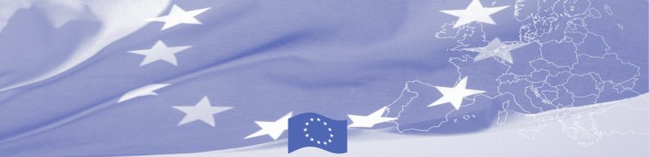

PRESS RELEASE

27 March 2015

EU project improved legal literacy among vulnerable groups of the South Kazakhstan region

SHYMKENT – On 27 March 2015, Eurasia Foundation of Central Asia (EFCA) organized the conference on the results of the "Strengthening CSO Networking for Human Rights Advocacy" project which was implemented with financial support of the EU Delegation to Kazakhstan from October 2012 to March 2015. The project budget comprised EUR 250,392.
The conference was attended by the representatives of EFCA, the project partners, rural NGOs and local authorities. Participants had an opportunity to discuss research and project results, encourage project partnerships, facilitate collaborative work in thematic workshops to address human rights and access to justice issues at local and regional levels.
The project aimed to strengthen the capacity of local civil society organizations in four regions of South Kazakhstan to effectively advocate for human rights and access to justice for vulnerable population, including rural women, at-risk children and youth and people with disabilities. The geographical coverage of the project included four regions of Kazakhstan: Almaty, Kyzylorda, Zhambyl and South Kazakhstan. Partners of the project were the Legal Center for Women’s Initiatives "Sana Sezim", "KAMEDA" Public Foundation and "Perekrestok" Public Foundation.
During the project the institutional capacity of South Kazakhstan NGOs was assessed and subsequently followed by a series of trainings on institutional development, human rights research, advocacy and social marketing. Additionally, NGOs conducted independent human rights issues research and15 NGOs implemented advocacy campaigns in their local communities. As a result, more than 2000 members of vulnerable groups received legal advice and appealed to legal authorities.
"Due to the remoteness of the district center, people with disabilities of Shelek region have little information and are not aware of their rights. The opening of counseling center in Shelek was a great event for people with disabilities in the region. This is a very important and exciting project,"- said the Head of the SCPP Kabylova Nilfara.
As a result of the project, a network of NGOs became more sustainable and effectively structured, and this has been recognized by representatives from the government sector. A Memorandum of understanding and cooperation with the representatives of the Department of the Interior and Internal Policy of the Southern region of Kazakhstan was signed within conclusion of the project.
For more information, please contact Raushan Kenzhetayeva, Project manager of the Eurasia Foundation of Central Asia, tel: + (727) 2501810 (112), raushan@ef-ca.org or Karlygash Jamankulova, Press and Information Officer of the EU Delegation to Kazakhstan, tel.: + (7172) 971148, karlygash.jamankulova@eeas.europa.eu
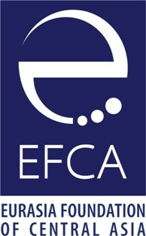
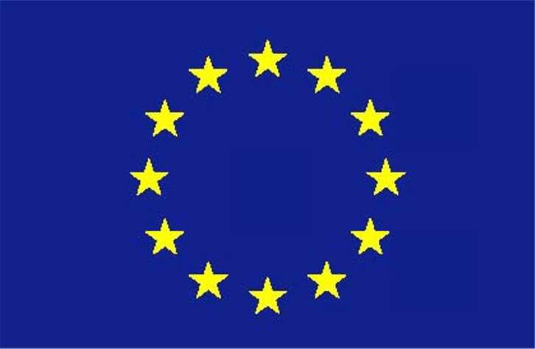
This project is funded by the
Delegation of the EU to Kazakhstan
62, Kosmonavtov Str,
010000 Astana
Tel.: (7172) 97-10-40
Fax: (7172) 97-95-63

This project is implemented by the Eurasia Foundation of Central Asia.
7A Biokombinatskaya Str. 050008 Almaty
Tel.: (727) 250-18-10
Fax: (727) 250-18-11

Eurasia Foundation of Central Asia (EFCA) is a public organization, established in the region in 2005. EFCA mobilizes public and private resources, helping citizens to take an active part in building their future by strengthening of local communities and enhancing of civil and economic welfare. EFCA continues activities of the Eurasia Foundation as a local institution. Eurasia Foundation is a private, nonprofit organization that has invested more than $ 40 million in Central Asia since 1993. For more information you can visit EFCA site: http://www.ef-ca.org
The European Union is made up of 28 Member States who have decided to gradually link together their know-how, resources and destinies. Together, during a period of enlargement of 50 years, they have built a zone of stability, democracy and sustainable development whilst maintaining cultural diversity, tolerance and individual freedoms. The European Union is committed to sharing its achievements and its values with countries and peoples beyond its borders.

